Sprint 2 - Accuracy Design Document

April 5th, 2023

Table of Contents
1. Executive Summary 3
1.1 Project Overview 3
1.2 Purpose and Scope of this Specification 3
2. Product/Service Description 3
2.1 Product Context 3
2.2 User Characteristics 3
2.3 Assumptions 3
2.4 Constraints 3
2.5 Dependencies 4
3. Requirements 4
3.1 Functional Requirements 5
3.2 Security 5
3.2.1 Protection 5
3.2.2 Authorization and Authentication 6
3.3 Portability 6
4. Requirements Confirmation/Stakeholder sign-off 6
5. System Design 6
5.1 Algorithm 6
5.2 System Flow 6
5.3 Software 6
5.4 Hardware 6
5.5 Test Plan 7
5.6 Task List/Gantt Chart 7
5.7 Staffing Plan 7

Executive Summary

Project Overview
Sphereo is an introductory program intended to introduce the user to basic procedural programming and implementing code that results in physical action being taken. Being a basic robotics program, the project is intended to give a surface-level understanding of robotics and programming that will be built upon with subsequent lessons.

Purpose and Scope of this Specification
In scope
- Creation of an algorithm that successfully runs the designated course
- Clean code will be provided that can be expanded upon for the next triathalon events
Out of Scope
- Making a program that exceeds the limits of the Sphereo hardware, by exceeding its maximum speed, endurance, etc.

Product/Service Description

Product Context
This product will demonstrate how Bluetooth can be utilized with creative hardware to create a new learning experience. The interface with which to plan out the algorithm is hosted within a phone app, and communicates with the sphere robot remotely. This Sphereo project relies on several already existing systems in order to function.

User Characteristics

One person utilizing this data would be an introductory computer science student, whom would use this product as a jumping-off point for further research into how robotics is coded. Little technical expertise is needed to utilize Sphereo, and thus the barrier of entry is low for anyone looking to learn from the algorithm. Block code provides this user with easy to understand building blocks for a deeper understanding of designing an algorithm.

Another type of person utilizing this product would be an instructor, either utilizing it as an example to share with future classes, or a method of judging the developer’s progress within the class. Knowing much more about computer science, the algorithm could potentially help the instructor in future lectures by providing a personal, organic result of their teachings.

Assumptions
Iphones and laptops capable of running Sphereo software will be available at all times. Bluetooth connectivity between developing hardware and the sphere will be present at all times. The operating systems for which our iPhones and laptops run on will be intact and running whenever needed.

Constraints
- Mac and iphone can get full data, including the motion chart, while normal pcs cannot.
- Time restriction is until the 23rd of March, 2023
- Triathalon algorithm must be easily shared between both developers, and agreed upon when finished.
- Framework must be concise before developing final algorithm.
- Speed must be implemented after a functional algorithm is developed

Dependencies
- Sphereo, as well as the operating system it runs on, must be updated to the latest versions.
- This product will require a download from Github
- The user must know how to translate the algorithm into the Sphereo progam.

Requirements

Functional Requirements
Req# | Requirement | Comments | Priority | Date Rvwd | SME Reviewed / Approved
Sprint_01 | Roll At 53 Speed | Approved. The course is run at a constant 53 speed | High | 3/30/23 | Approved
Sprint _02 | Create a figure 8 motion with Sphero | Approved and Discussed of how we will make it work | High | 4/2/23 | Approved
Sprint _03 | Ensure figure 8 motion aligns with floor path | Approved and Discussed | High | 4/2/23 | Approved
Sprint _04 | Repeat figure 8 pathing four additional times to reach course requirements. | Approved. Figure 8 motion is consistently staying on course. | High | 4/2/23 | Approved
Sprint_05 | Speak “ I am the winner” and flash multicolored lights | Approved. Robot says designated voiceline, along with specific lights. Additional voiceline was added | Low | 4/3/23 | Approved

Security

Computers containing Data required to use the robot will only be in personal devices (Victor and Jack’s Computers).

Protection

All data will be saved locally, and confined to two flash drives containing all of the data. A VPN will be used to ensure computer security is not breached.

Authorization and Authentication
Only Jack and Victor are authorized to work on this assignment. Authentication will involve solely working with each other on the project

Portability
Code will be posted to github, making it easily downloadable for anyone looking for an introduction to Sphereo.

Requirements Confirmation/Stakeholder sign-off
Meeting Date | Attendees (name and role) | Comments
3/30/23 | Victor and Jack | Collaboration on algorithm, as well as sharing of ideas for development. Confirmed basic ideas
4/1/23 | Victor and Jack | Algorithm confirmed, testing in next few days
4/5/23 | Victor and Jack | Video taken, successful application of algorithm
4/5/23 | Victor and Jack | Final project uploaded

System Design

Algorithm
- Start Program
- Set speed at 53
- Loop steps 4 and 5 five times over
- Spin 360 degrees for 9 seconds
- Spin -360 degrees for 9 seconds
- Pause
- Play fart noise, wait
- Speak: “I am the winner”, continue
- Strobe red and blue lights
- Exit program

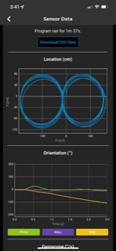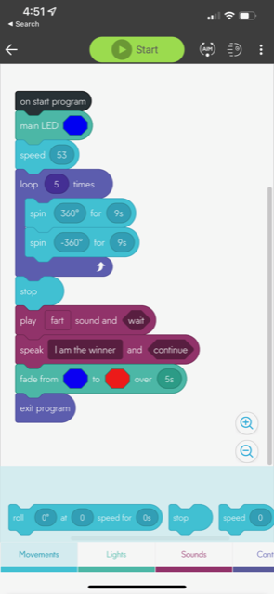

System Flow
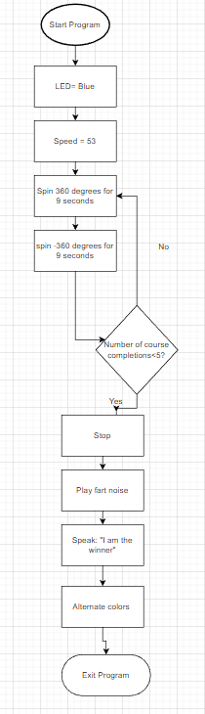

Software
Sphereo’s programming relies on javascript, and is hosted on the Sphereo app. Flowcharting and designing of the program will be done using draw.io

Hardware
A Mac computer, as well as an iphone 12 will be used to develop, test, and apply the algorithm for the entirety of the project.

Test Plan
Include a test plan showing all unit tests performed for this application, Include test rational, test date, staff member, pass/fail status

Reason for Test Case | Test Date | Expected Output | Observed Output |  | Staff Name | Pass/Fail
Test for Completion and Accuracy of Block Code | 03/30/2023 | The Robot to traverse through the figure 8 while staying on the line | The Ball was going too fast to make accurate turns | Victor and Jack |  |  | Fail
Test for Completion and Accuracy of Block Code with altered block code | 03/30/2023 | The Robot to traverse through the figure 8 while staying on the line with new speed | The Angles were slightly incorrect and didn’t traverse the course as accurately as preferred. | Victor and Jack |  |  | Fail
Test for Completion and Accuracy of Block Code with altered block code | 04/3/2023 | The Robot to traverse through the figure 8 while staying on the line with new speed (1 Singular Time) | The Ball traversed the course accurately enough one time. | Victor and Jack |  |  | Pass
Test for Consistency of Block Code | 04/2/2023 | The Robot to traverse through the figure 8 five consecutive times | The Ball traversed the course accurately 5 times | Victor and Jack |  |  | Pass
Final Test | 04/5/2023 | The Robot to traverse through the figure 8 five consecutive times accurately | The Ball traversed the course accurately 5 times | Victor and Jack |  |  | Pass

Task List/Gantt Chart

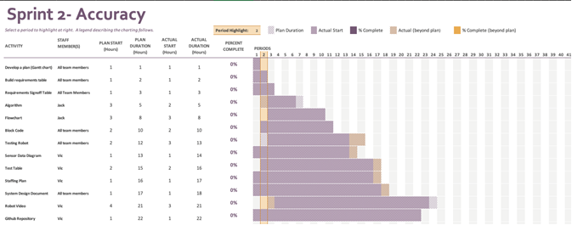

Staffing Plan

Name | Role | Responsibility | Reports To
Jack Miller | Lead Developer | Develop algorithm for Sphereo | Victor
Victor Davidson | Project Manager | Ensure deadlines are met, communications are frequent | Jack

